*\*\*STATE DIAGRAMS ABOUT 1-4 REQUIREMENTS****\*\****

Object 1: Customer – State Diagram

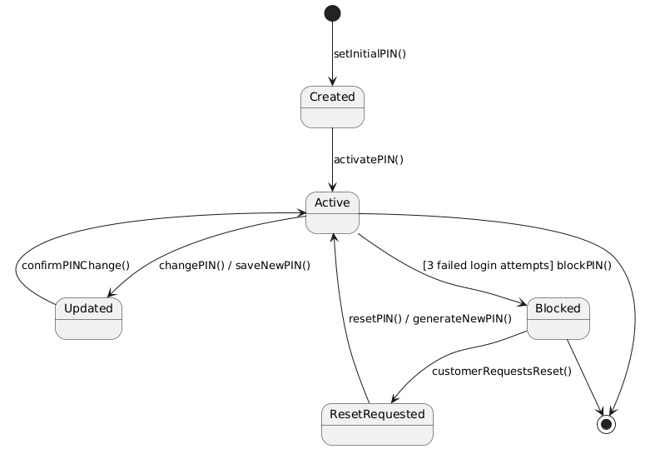

Object 2: PIN – State Diagram

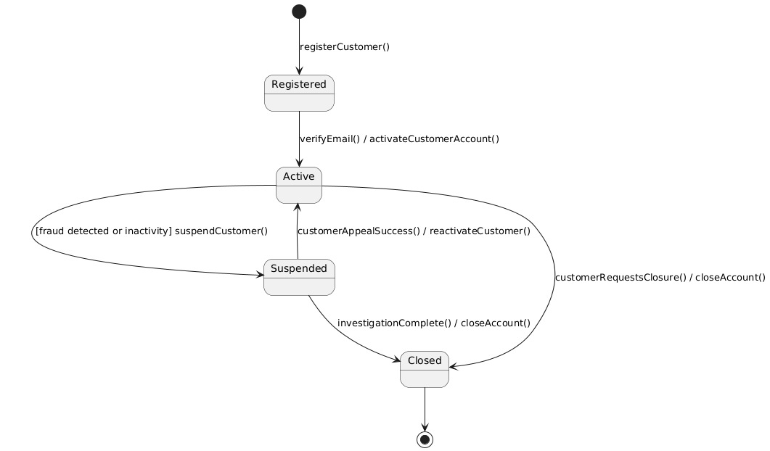

Object 3: UserSession – State Diagram

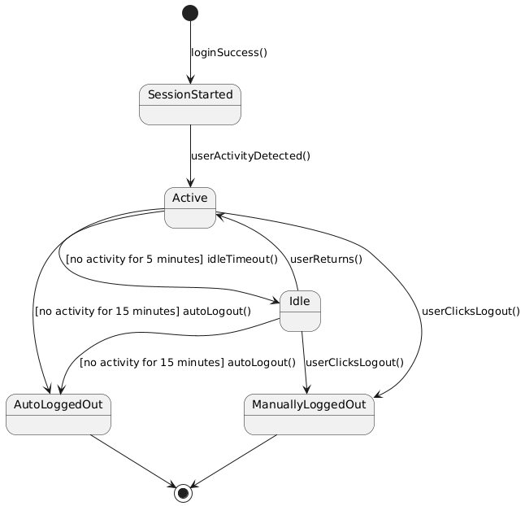

1. Customer shall be able to create a bank account and view account balance

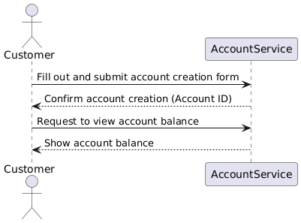

1. Customer shall be able to transfer money and receive transaction alerts

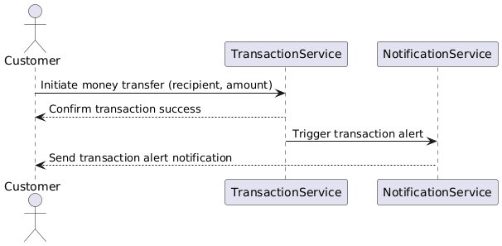

1. Customer shall be able to apply for and view their loan details

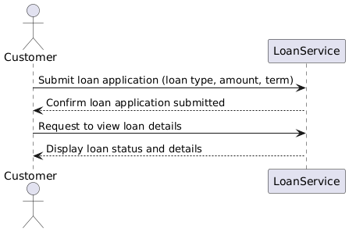

1. Customer shall be able to manage cash (withdraw/deposit) and update personal information

